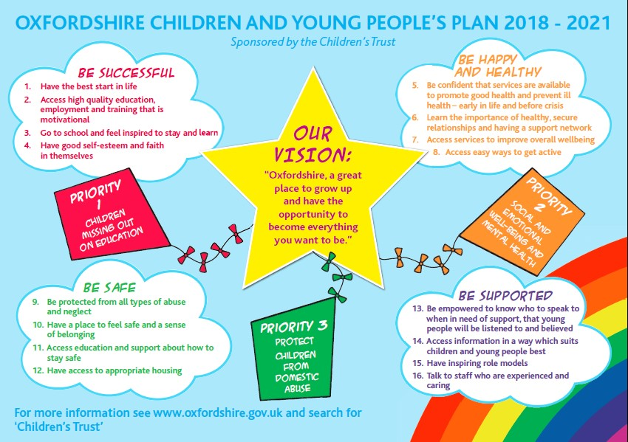
Areas of Focus | Actions  All priority areas to include a focus on children who are being exploited | Responsible agencies | How we will know this area of focus has improved | Children’s Trust Board Lead | Reporting Timetable
Be Successful  FOCUS ON CHILDREN WHO ARE NOT ENGAGED IN EDUCATION | - Develop inclusive practice and provision in order to improve the progress and life chances for our SEND, vulnerable and disadvantaged learners.  - This action will be reviewed and revised in September 2020 when the impact and extent of schools’ recovery is clearer, to be encompassed in regular reporting cycles. | - County Council – education service  - Early Help/LCSS  - City & District Councils  - Health Visiting  - Schools and Early Years settings  - School health nurses  - CAMHS  - Community & Voluntary Sector  - Thames Valley Police  - Oxfordshire Strategic Schools Partnership | - Compare 2019-20 attendance data with national and statistical neighbours to identify strengths and areas for improvement. Vulnerable groups attendance at school will be drilled down with Social Workers to children with Child Protection and Child in Need plans.  - Impact of not being in school on other risk factors e.g. child exploitation, youth crime, mental health, substance misuse etc. Education input to optimise school attendance to national or better.  - Compare Oxfordshire attendance data from April-July 2020 to September to December 2020  - Establish an Elective Home Education parents’ virtual network  - Identify electively home educated children on Child Protection and Child in Need Plans for focussed joint work with allocated Social Workers  - Track Ofsted outcomes when inspections resume pertaining to Recovery Curriculum impact  - Track Ofsted and School Improvement Partner findings on each school’s development of inclusive curricula and practices.  - Measure the use of Bereavement support resources shared by OCC education services by assessing rates of downloading of those materials  - Measure impact of transition work by tracking Ofsted and School Improvement Partner findings  - Measure impact on EHCP timeliness and quality by drawing on SEND QA Panels findings. | Chris Hilliard/ Hayley Good/ Jayne Howarth, Debbie Bell | Sept 2020
Be Healthy  FOCUS ON SOCIAL, EMOTIONAL, PHYSICAL & MENTAL WELL BEING | - Plan our recovery as a system (Health, Children Services and Education) and that joint plan will have an emphasis on prevention working with Public Health. We will use the school survey undertaken by public Health for our planning as well as evidenced based modelling.  - Undertake a systems gap analysis with regard to the impact of COVID including expected backlog, expected surge, impact of redeployment where relevant and potential reduced staff capacity due to self-isolation and illness.  - Put multi agency network meetings (Health, Children’s Services, Education, Police and voluntary sector partners) in place to mitigate against expected surge and also the unknown impact of COVID we may discover in due course as society returns to the new normal.  - Use Trauma informed practice and other evidenced based interventions in our work with children and families. | - County Council – Early Help  - City & District Councils  - Public Health  - Health  - Schools  - Community & Voluntary Sector | - Systems partners are committed to prevention and early help where appropriate  - Disseminate school survey and share findings to identify need and support planning for recovery  - Total number of children and young people that had a 1:1 intervention by the Public Health Workforce (School Health Nurses) at an attended appointment for resilience and emotional wellbeing during the academic term (primary, secondary and colleges)  - MHSTs to support Primary and Secondary Schools in Pilot schools to develop their Whole School Approach including having nominated Mental Health Leads  - Developing local community networks to support EHAs  - Once networks are developed it is anticipated that they will support up to 2000 EHAs a year  - Continue to increase the proportion of children with diagnosable mental illness, accessing CAMHS (national measure) | Maria Godfrey, Lajla Johansson, Emma Leaver, Donna Husband, Vicky Norman, Sarah Breton, Alex Davis | December 20
Be Safe  FOCUS ON DOMESTIC ABUSE | - A multi-agency group looking at recovery from domestic abuse for adults and children has identified a gap in support for children recovering from the effects of domestic abuse in their family which is likely to be exacerbated by the Covid-19 movement restrictions. This group will link with Family Solutions lead to ensure that this need is addressed and that this fits within the broader CEF response for children impacted by domestic abuse.  - Oxfordshire County Council’s Strategic Lead for Domestic Abuse will work with CEF and TVP domestic abuse leads to test out the effectiveness of Operation Encompass, make recommendations to optimise this initiative and develop best practice guidance for schools.  - The Strategic Lead for Domestic Abuse will support mobilisation of the contract to deliver the domestic abuse element of CEF’s new Family Safeguarding Plus Model (FSPM). Launching in September 2020 this new service will include ten commissioned specialist domestic abuse workers to work across County and will be embedded within FSP teams. There will be specialist workers for both victims/survivors and perpetrators of domestic abuse, to reduce the impact of parental domestic abuse on children within the family, and as such improve outcomes. | - Domestic Abuse Strategic Board | - Improved knowledge of the barriers children and young people traumatised by domestic abuse face in accessing appropriate support  - Increased understanding of gaps in support for children and young people traumatised by domestic abuse  - Identification of options to address barriers and gaps in support and in response to this a multi-agency plan agreed with our Operational and Strategic Domestic Abuse Boards.  - Increased number of Operation Encompass notifications to schools  - All schools will receive best practice guidance in relation to how to respond Operation Encompass notifications  - Improved outcomes for children in families affected by domestic abuse as set out in the FSPM domestic abuse contract with the provider delivering the service. | Sarah Breton, Sarah Carter | March 21
Be Supported | - Consultation revised to ensure it is accessible to children with disabilities/SEND  - Repeat survey | - VOXY & Engagement  Team | Use 2019 & 2020 surveys as benchmark for improvement | Rosie Boyes VOXY Reps | Sept 20  Jan 21

